**CRM Analysis Report for Weee!**

**“Weee! Are the Champion”**



**Customer Relationship Management**

BU.420.720.83.SP22

Group 2: Sarah Chen; Gemma Liang; Lillian Xie;

Haoxiong Qin; Pariya Pusayapaibul; Rajshree Bagadia

**Table of Contents**

1. Client Summary

2. Current CRM Strategy & Vendor Analysis

3. Other CRM Vendor Analysis

4. Recommendations

5. Current CLV vs Future CLV

6. Reference

7. Appendix

**1. Client Summary**

1. Company/Organization As-Is/To-Be Position

**As-Is Position:** Enable affordable access to groceries and to deliver hard-to-find goods directly to customers.

**To-be position:** Become one-stop service for food supply by expanding service areas and ecosystem.

1. Company/Organization Offering

**Offering:** Weee! is the largest online grocery store, which specializes in Asian and Hispanic food in North America.

1. Company/Organization House File Overview

Weee only has one subsidiary called RICEPO, which is a Chineses food delivery App. RICEPO was founded in New York in 2013 and now has its headquarters in Silicon Valley. "The addition of RICEPO will let us continue to delight and serve our growing customer base as a one-stop shop for delicious food at home," Weee! founder and CEO Larry Liu said in a news release. The RICEPO acquisition, Weee! stated, will help the company meet the "growing demands of customers nationwide seeking diverse and authentic food-at-home options." (Grace, 2021)

1. Target Audience(s) Analysis

The next goal of Weee!’s regional expansion is to cover 30 cities across the United States. In terms of minority users acquisition, Weee! will continue to target Asian and Hispanic, and even market segments such as Cuban, Japanese, Korean, Vietnamese and so on. According to Larry, the founder of Weee!, the minority population in the United States is now as high as 90 million, accounting for 30% of the total population. In the future, it will maintain an annual growth of 3-5%. That means the minority grocery e-commerce market is an incremental market, and these users' annual food consumption in the United States will reach US $470 billion in 2023. (36 Ke, 2022)

1. Customer Journey Analysis (See figure 1.0)

1. Digital Ecosystem As-Is/To-Be Overview

Weee! currently does not have an integrated It has its own logistics system and dashboard where they collect all the consumer data, and global network of supply chain, and also it has a subsidiary called Ricepo which is a Chinese food delivery application. Other than those, Weee uses applications outside of the company for advertising and data analytics.

And our suggestion for the future change is that firstly, to build a stronger and consistent ecosystem, Weee! should use a consistent brand style guide. Secondly, avoid vendor lock-in. Finally, the ideal goal is to integrate all the functions in one platform, and have 100% control over all the data. (See figure 2.0)

1. Industry Highlights

As for the whole e-grocery industry, there are surveys showing that grocery e-commerce is going to double in the next five years, which means this industry is promising and profitable while it also means that there will be more competitors. (See figure 3.0)

What’s worth mentioning is that online delivery orders increased about 50% during the Covid-19 outbreak and are expected to rise further in 2022. So compared with retailers, online grocery can be more profitable in the pandemic. (See figure 3.1)

1. Competitor Review & Positioning

There are a few online direct competitors of Weee, which are Umami cart, Yamibuy Freshgogo, and Sarapnow. (See figure 4.0)And offline retailers are also competitors of Weee, which are Great Wall supermarkets and H mart. But in this case, we only focus on online e-grocer.

Here is the positioning map, (See figure 4.1) we can see now Weee is actually at the top right among all competitors. And we want to move further to the top right corner, where we’d like to provide the widest range of high-quality products with the shortest delivery time.

1. SWOT Analysis (See figure 5.0)

**2. Current CRM Strategy & Vendor Analysis**

Please refer to Table 1 and Table 2 for this part.

**3. Other CRM Vendor Analysis**

Based on the problem Weee! has in its current system, we give Integration, Reporting/Analytics, Automation, and Future Friendly more weight in the calculation. (Refer to Table 3 to Table 9)

**4. Recommendations**

*Acquisition*

App users generate the highest revenue, so we want to attract more people to download our APP. Our current benefit for new users is $10 Off on first order, and we want to change that to $15 off only for App users. And we want to offer a 21-day free trial of VIP for new consumers. Because we believe 21 days can make consumers cultivate the habit of buying products from our brand. And we also want to launch a new student program, where students can use their school address to register accounts and will automatically have a 3-month free trial.

Invest more in email and app push marketing.

*Retention*

we want to provide more benefits to our VIP. So that we can attract more people to buy our membership in a way to increase consumer loyalty. For example, like small gifts and vouchers. Increase follower engagement on social media and WeChat to earn more WOM effect. Lastly, personalized product recommendations will increase the consumers’ buying desire.

*Reactivation*

To those who haven’t ordered for more than 1 month, we want to send them emails or wechat notifications to remind them to use the $10 coupon.

**5. Current CLV vs Future CLV**

Please refer to Figure 6.0 to Figure 11.0 for this part.

**Reference**

1. Moran, C. D. (2021, May 13). *WEEE taps former Instacart Marketing Executive*. Grocery Dive. Retrieved May 19, 2022, from https://www.grocerydive.com/news/weee-taps-former-instacart-marketing-executive/600117/
2. McKinsey & Company. (2022, April 29). *The next horizon for grocery e-commerce: Beyond the pandemic bump*. McKinsey & Company. Retrieved May 19, 2022, from https://www.mckinsey.com/industries/retail/our-insights/the-next-horizon-for-grocery-ecommerce-beyond-the-pandemic-bump?cid=eml-web
3. Vaughan, K. (2022, March 18). *9 best online grocery stores so you never have to leave your House*. Food52. Retrieved May 19, 2022, from https://food52.com/blog/27213-best-online-grocery-stores
4. Grace, C. L. F. (2021, October 22). Online grocer WEEE! buys ricepo delivery company. Winsight Grocery Business. Retrieved May 20, 2022, from <https://www.winsightgrocerybusiness.com/retailers/online-grocer-weee-buys-ricepo-delivery-company>
5. 36 Ke. (2022, March 1). American Grocery E-Commerce Platform “WEEE!” Completed the E-Round Financing of US $425 Million. Retrieved May 19, 2022, from https://baijiahao.baidu.com/s?id=1726050627306886078&wfr=spider&for=pc

**Appendix**

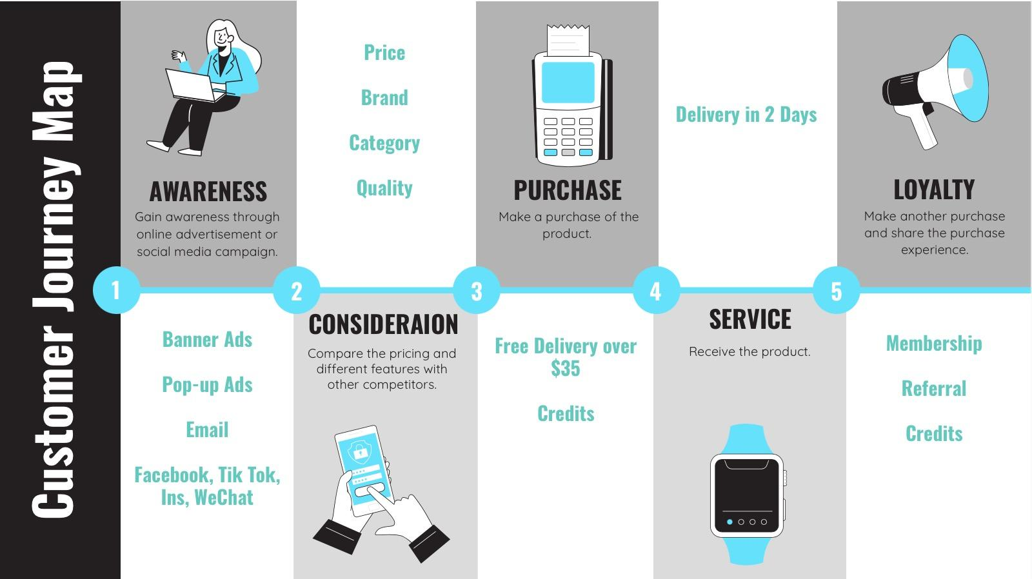

Figure 1.0 Customer Journey Map

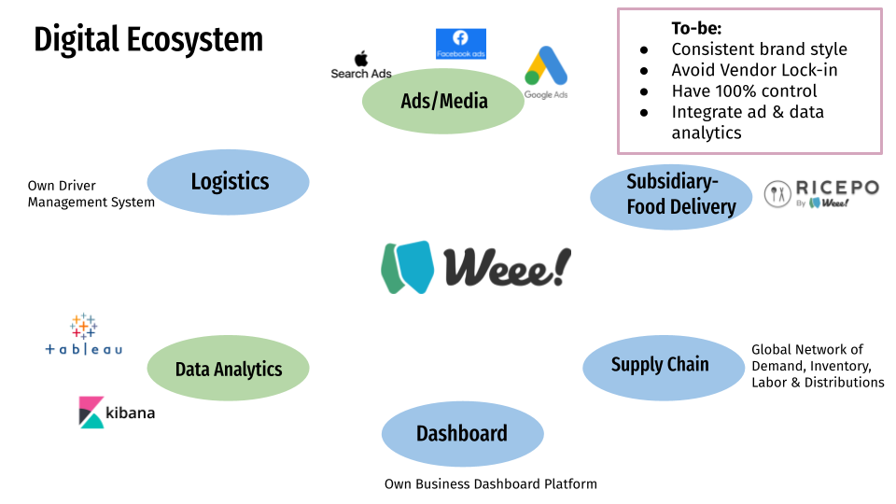

Figure 2.0 Digital Ecosystem of Weee!

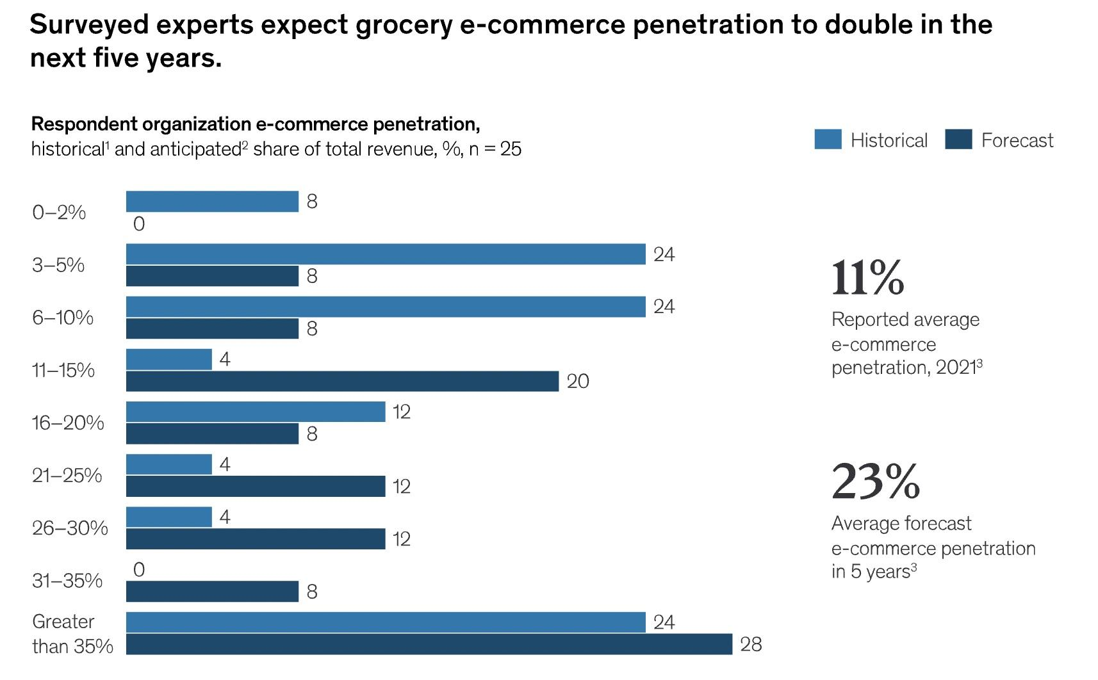

Figure 3.0 Survey Results

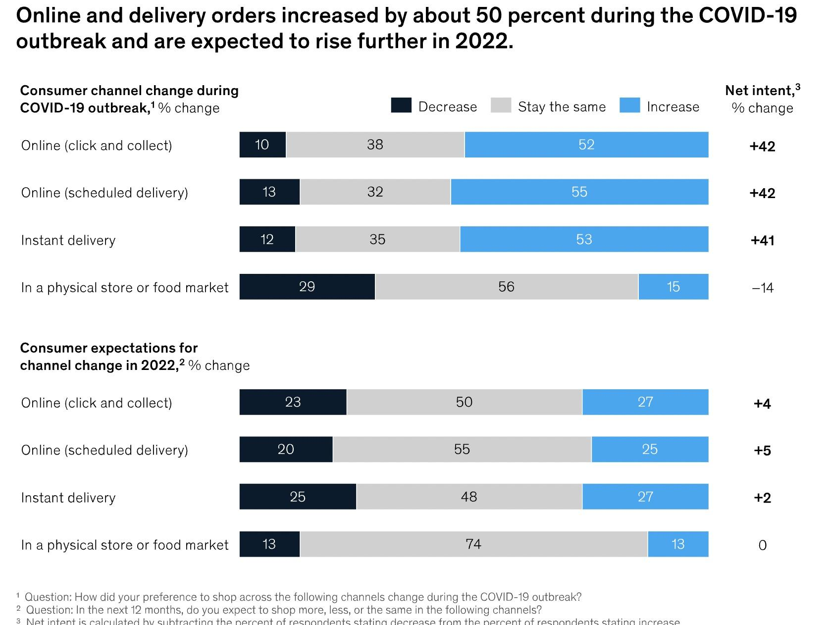

Figure 3.1 Survey Results

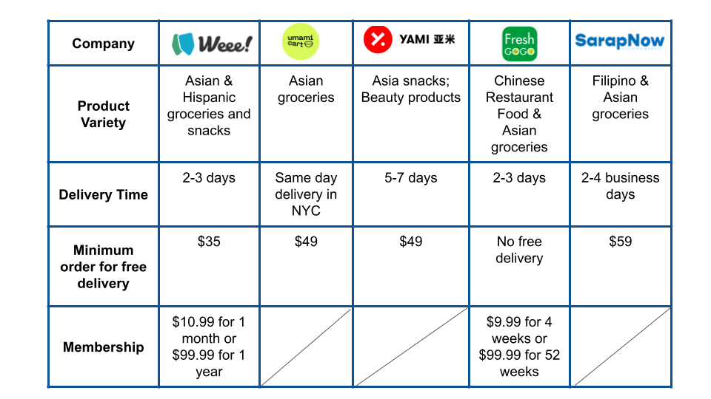

Figure 4.0 Weee’s Competitors

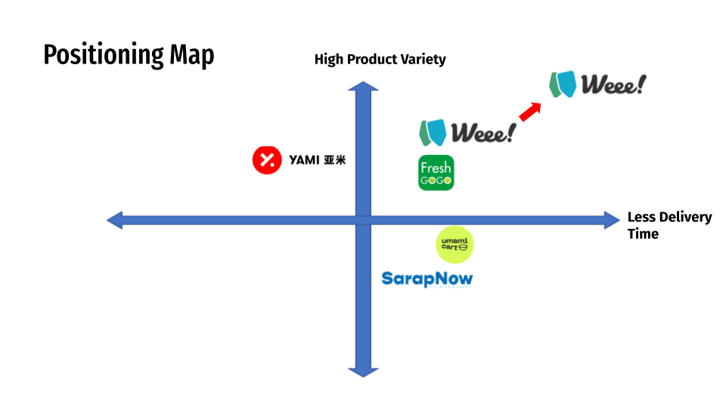

Figure 4.1 Positioning Map

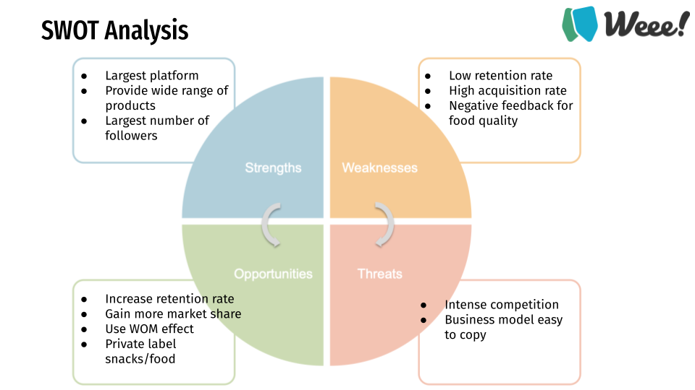

Figure 5.0 SWOT analysis of Weee!

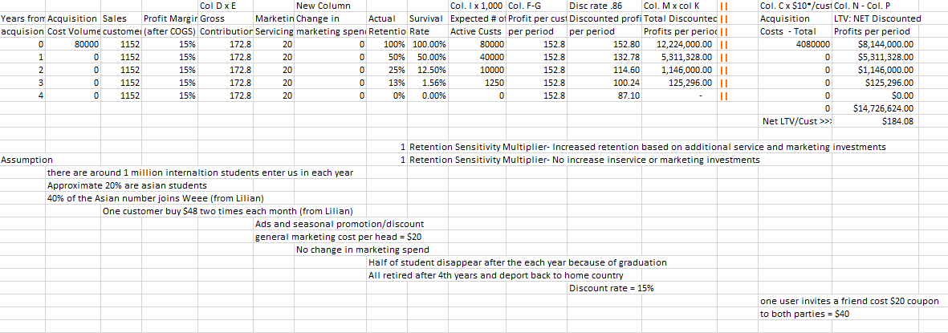

Figure 6.0 Base case CLV for Asian students

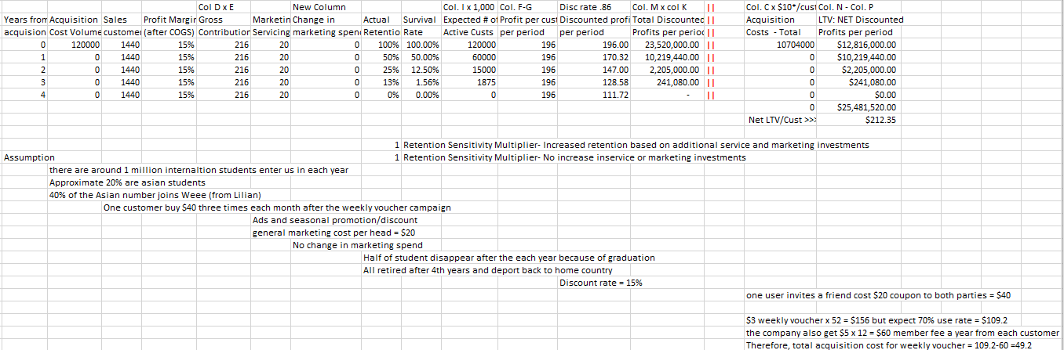

Figure 7.0 CLV of $3 weekly voucher giveaway case for Asian students

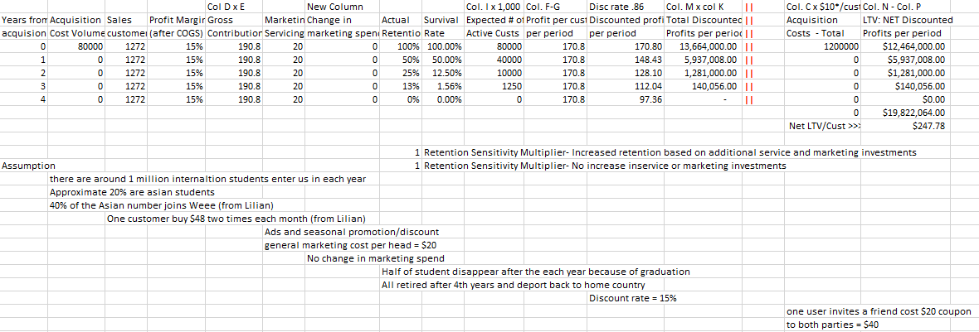

Figure 8.0 CLV of $15 discount for the first time APP registration case for Asian students

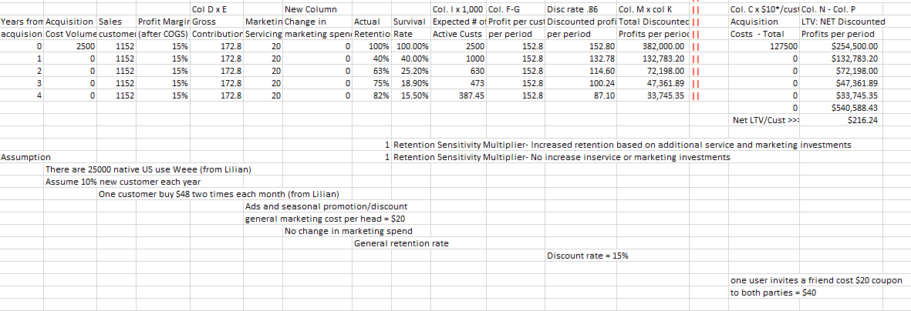

Figure 9.0 Base case CLV for local US customer

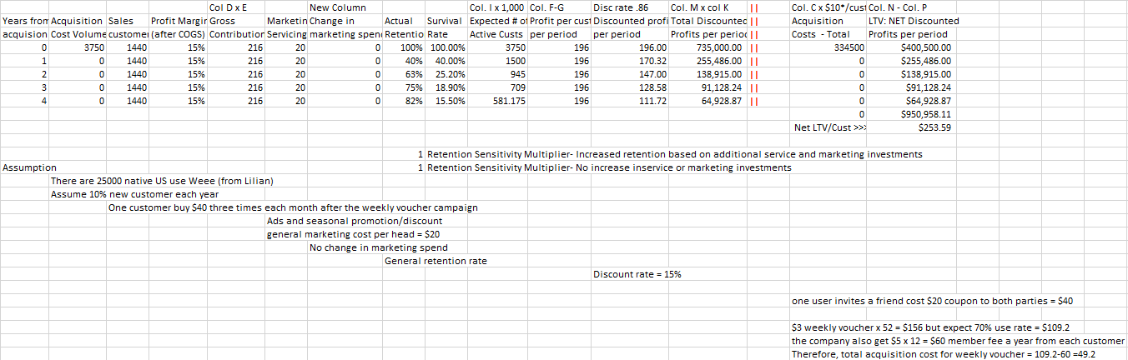

Figure 10.0 CLV of $3 weekly voucher giveaway case for local US customers

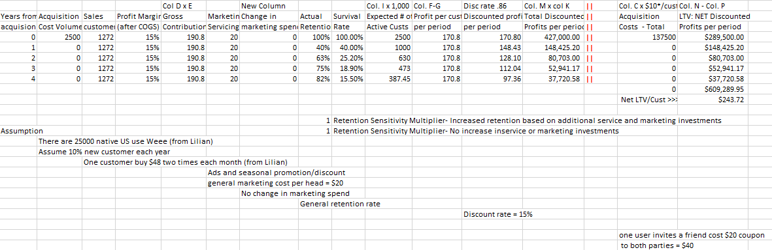

Figure 11.0 CLV of $15 discount for the first time APP registration case for local US customers

**Table 1: CRM Strategy Analysis**

| **CRM Strategy Rubrics** | **Evaluation of Weee’s CRM strategy** |
| --- | --- |
| **Customer Management**  What are the organizational values and beliefs, and can they be transformed into strategic customer management principles that management is committed to implementing? | As Weee has realized its mission to become the top grocer for Asian consumers in North America, the fast-growing California-based e-grocer has set its sight on a larger goal: **becoming the one-stop shop for food across ethnicities**. The ultimate goal of Weee can be transformed into the following strategic customer management principles: In-depth knowledge of all potential customers of all ethnicities in the US  * Treat customers as assets as growing * Link the company’s customer strategy to its overall identity and culture |
| **Organizational Process Integration & Alignment**  Is there an organization-wide creation and synchronization of processes and systems that enable the implementation of customer management principles? | The company utilizes its own platform to manage daily operations. However, it lacks a more comprehensive CRM system to grasp useful customer information, serve them all-around and form a positive cycle to attract new customers and implement the CRM principles mentioned above. Currently, they are order-centric rather than customer-centric, and they lack a cohesive solution to implement the principles into business activities. |
| **Data Capture & Technology Integration & Alignment**  Does the company or organization have all the necessary technology and processes to collect, store, and to process relevant and timely customer information? | The company is growing at a really fast pace and it is hard to judge their competence based on the information we have gathered so far. The dashboard Weee is using is developed by its own engineers and the framework can be tailored and updated easily(if certain advancement is promised). The system is able to collect and store RTG data (Real-Time Gross), however some complex analysis are often conducted outside the system. So the process stage is tricky for Weee’s current CRM system. |
| **CRM Strategy Implementation**  Is there an acquisition, retention and reactivation process that is implemented that continuously aligns the offering with customer needs and values? | Since the switching cost on the consumers’ side is relatively low, the customer management system needs to build a customer database to predict their preferences and buying patterns, in order to attract more deals. The lack of a comprehensive CRM system makes Weee fails to leverage other users' data to predict one user’s behavior.  Especially for retention and reactivation, the system lacks user-centric algorithms or mechanisms that can release or recommend new products specific to each customer’s specific needs. |

**Table 2: CRM Vendor Analysis**

| **CRM System Evaluation Rubrics**  **Vendor Name: Weee’s Dashboard** | **Rating** | **Reasoning** |
| --- | --- | --- |
| **Cost:** What are the real costs and value of the CRM system relevant to the client’s size, scope and mission statement? | 2 | Weee managed to become the leading Asian grocery eCommerce platform in the US with their dashboard satisfying daily business management basically. However, their CRM system is based on order-level rather than customer-centered, which is one of the reasons why reactivation is so costly because they cannot accurately identify customers with higher CLV. |
| **Implementation:** What are the steps that need to be taken to implement and launch a new CRM system while incorporating a CRM strategy? | 2 | Because Weee does not have a separate CRM system outside the its own dsahboard, we propose it deploy a brand new system. Hence, it is rather difficult to launch and get used to the new system.  The steps of launching a new CRM strategy can be briefly described as follows: system setup and trail run; automation; staff training; landing the system to daily use. |
| **Integration:** What marketing channels and MarTech systems does the CRM system support and/or plug into? | 2 | Besides Weee’s own dashboard, two visualization tools Tableau and Kibana are used to analyze & visualize large datasets. The client should be glad to switch to a more integrative system that can both support daily operations and work smoothly with big data. |
| **Mobility:** Is the system virtually accessible to anyone authorized to utilize it and is it responsive? | 3 | The system is cloud-based and designed to have limited access for different employees from different departments. Most of the data are real-time hence responsiveness is good. |
| **Reporting/Analytics:** What reporting capabilities does the CRM system have and are they customizable? | 2 | Weee’s dashboard is highly capable of monitoring KPIs while less functional in drawing conclusions and output reports and insights. Most analyses are conducted outside the system in tableau and kibana. These two tools generate traffic channel, SKU count, revenue by region, new buyers by region, buyer ethnicity by store. These outputs are only used in weekly report or higher-up meetings. |
| **Adoption:** How easy and likely is the CRM system to be adopted and embraced by the company or organization? | 4 | The system is self-built, so it is highly adjustable and user-friendly to the organization. It encompasses every aspect of the business. |
| **Automation:** Does the system lend itself to salesforce automation and can it be automated to realize force multiplier advantage? | 2 | The repetitive tasks (like creating records of orders and deliveries, sales ranking breakdown types of clients, refund overviews, etc.) have been generally reduced through automation. However, the info integration across different charts still requires human effort. |
| **Scalability:** Can the system be scaled both up and down rapidly based on requirement? | 4 | The scaling is optional and this is benefitted by the engineers of Weee behind the self-built system. |
| **Customizability:** Can the CRM system be customized and what are the costs associated with such customizability? | 4 | Not quite many costs since the system is built by Weee themselves. |
| **On/Off-Premise:** Is the service hosted and delivered from a location that belongs to the CRM service provider or the client? | 4 | Client owns the system. |
| **Future Friendly:** Will this CRM system be viable and in-business into the foreseeable future? | 1 | In general, the CRM system embedded in the dashboard of Weee helps its employees to keep track of daily business flows. However, the system is not capable of managing large data that involves complex analysis. In the long run, Weee will devote much more time to customer targeting, retention and reactivation, which requires in-depth analyses and evaluation that the current system cannot offer.  Moreover, this CRM system is not independent and user-centered, which makes it lacks insights generation that allows people to make sense of the gathered data. In order to be more competent in the future, the CRM system needs to be upgraded, like converting gathered data into more comprehensive and appealing charts, graphs and spreadsheets that allow people effectively measure business activity outcomes and achieve business goals. |
| **Data Access & Ownership:** Who owns that data and is it easily accessible and transferable? | 3 | The company owns all the data and often transfers the data to other platforms for deeper analysis. |
| **User Experience (UX) and User Interface (UI):** Does the system have user-friendly and intuitive interface and administrative controls. | 3 | The dashboard is pretty straightforward, and the sections clearly divided. However, the system can be built more intuitively based on different stages of their business (before and after purchase) or on different segments of business (orders, products, clients, delivery, campaigns). |
| **Security and Redundancy:** How secure is the CRM system and what risks are associated with shared tenent resources? | 4 | As stated before, this is a private-owned, self-built system, so it is well-protected. |
| **Customer Service:** How robust and comprehensive is the service-level support? | 3 | For the vendor itself, there are detailed charts that support customer refund process. For example, there are graphs on RTG Customer experience which provides detailed information on refund amount, refounder’s business type, percentage of order refunded, etc. broken down by different refund reasons.  For the website, Weee provides vigorous Q&A, email contact, and 24/7 customer service via phone that allows feedback on product quality/change receive time/scheduled delivery time/cancel order/manual service. In the future, like many other eCommerce platforms, Weee can deploy AI-powered chatbots or self-service options to ensure customers can get help outside of normal business hours. |

**Table 3: Evaluation Weight Model for Vendors’ Comparison**

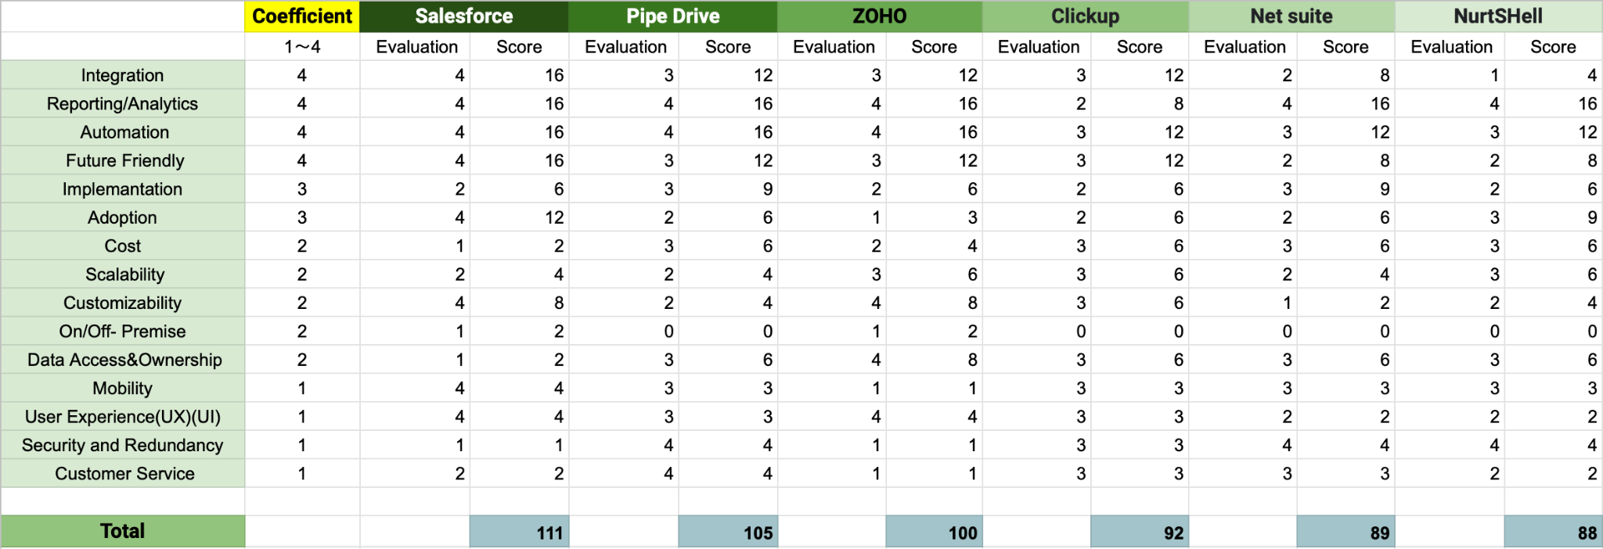

**Table 4: Clickup matrix Vendor Analysis**

| **CRM System Evaluation Rubrics**  **Vendor Name:** | **0 (Does Not Apply)** | **1 (Does Not Meet Client's Needs)** | **2 (May Not Meet Client's Needs)** | **3**  **(Meets Client's Needs)** | **4 (Goes Above & Beyond Client's Needs)** |
| --- | --- | --- | --- | --- | --- |
| **Cost:** What are the real costs and value of the CRM system relevant to the client’s size, scope and mission statement? |  |  |  | $19 per customer per month |  |
| **Implementation:** What are the steps that need to be taken to implement and launch a new CRM system while incorporating a CRM strategy? |  |  | Variety of features so may take time to learn about the feature therefore, high training cost |  |  |
| **Integration:** What marketing channels and MarTech systems does the CRM system support and/or plug into? |  |  |  | Yes, It can be integrated with 50 plus Martech Tools along with plug-ins like Miro, Figma, Harvest, Salesforce, etc |  |
| **Mobility:** Is the system virtually accessible to anyone authorized to utilize it and is it responsive? |  |  |  | Yes, It is and can be accessed through phone cloud, etc |  |
| **Reporting/Analytics:** What reporting capabilities does the CRM system have and are they customizable? |  |  | Organize your accounts in a list, Kanban board, or tables for quick data entry. ClickUp's 10+ flexible views make it easy to manage everything from sales pipelines to customer orders, Additionally, Create high-level views to monitor customer lifetime value, average deal sizes, and more. ClickUp's 50+ dashboard widgets make it easy to visualize all of your customer data in one place. As this only provides high level view of data visualization and analysis |  |  |
| **Adoption:** How easy and likely is the CRM system to be adopted and embraced by the company or organization? |  |  | It is comparatively easy to use than the current dashboard which wee uses and therefore as clickup does not provide any language options |  |  |
| **Automation:** Does the system lend itself to salesforce automation and can it be automated to realize force multiplier advantage? |  |  |  | Automations based on the routine work as well as customize based on their user needs |  |
| **Scalability:** Can the system be scaled both up and down rapidly based on requirement? |  |  |  | Yes, it can be scaled based on customer requirements |  |
| **Customizability:** Can the CRM system be customized and what are the costs associated with such customizability? |  |  |  | yes - you can customise your own CRM dashboard.   Business Plan ($9/month per user):  Features:  All Unlimited Plan features  Work In Progress Limits  Granular Time Estimates  Unlimited Custom Exporting  Form branding and customization |  |
| **On/Off-Premise:** Is the service hosted and delivered from a location that belongs to the CRM service provider or the client? | Works only on cloud |  |  |  |  |
| **Future Friendly:** Will this CRM system be viable and in-business into the foreseeable future? |  |  |  | Yes, the CRM is viable as the cost for business needs is just $9/person/month which is way less than the amount of revenue earned by the company every day. |  |
| **Data Access & Ownership:** Who owns that data and is it easily accessible and transferable? |  |  |  | Yes, the data can only be accessed by the individuals who have been provided the access by the company and the data transfer capability is also up to the mark _____ need to find the value |  |
| **User Experience (UX) and User Interface (UI):** Does the system have user-friendly and intuitive interface and administrative controls. |  |  |  | Yes, the System have a better UI and UX compared to the one used by Weee |  |
| **Security and Redundancy:** How secure is the CRM system and what risks are associated with shared tenent resources? |  |  |  | Yes |  |
| **Customer Service:** How robust and comprehensive is the service-level support? |  |  |  | Yes |  |

**Table 5: Salesforce analysis Vendor Analysis**

| **CRM System Evaluation Rubrics**  **Vendor Name:** | **0**  **(Does Not Apply)** | **1 (Does Not Meet Client's Needs)** | **2 (May Not Meet Client's Needs)** | **3 (Meets Client's Needs)** | **4 (Goes Above & Beyond Client's Needs)** |
| --- | --- | --- | --- | --- | --- |
| **Cost:** What are the real costs and value of the CRM system relevant to the client’s size, scope and mission statement? |  |  | **(billed annually) Commerce Cloud Service B2B2C: 1% Gross Merchandise Value + Order management: 20 locations $0.3/order; 500 locations $0.5/order**  **(* This edition requires an annual contract and a 20,000 order minimum.)** |  |  |
| **Implementation:** What are the steps that need to be taken to implement and launch a new CRM system while incorporating a CRM strategy? |  |  | **Too much cost for training employees, switching cost and hidden cost which is customization method,( ad ons )** |  |  |
| **Integration:** What marketing channels and MarTech systems does the CRM system support and/or plug into? |  |  |  |  | **more than 200 technology partners, APPExchange;**  **ordering command center, where you can customize the processing, shipping, and delivery processes using simple drag-and-drop tools. No coding required. You will also have the option to automate payment capture and invoices** |
| **Mobility:** Is the system virtually accessible to anyone authorized to utilize it and is it responsive? |  |  |  |  | **Salesforce turns your mobile device into a portable sales office. You can log calls, respond to hot leads, work opportunities, or check dashboards, no matter where you are. And with mySalesforce, the experience can be customized to match your brand.** |
| **Reporting/Analytics:** What reporting capabilities does the CRM system have and are they customizable? |  |  |  |  | **7 Reports:**  **https://weareuv.com/what-analytics-does-salesforce-commerce-cloud-provide/#:~:text=These%20reports%20allow%20you%20to,well%20as%20the%20ordered%20products.** |
| **Adoption:** How easy and likely is the CRM system to be adopted and embraced by the company or organization? |  |  |  |  | **multi-langague; multi-location; global currency** |
| **Automation:** Does the system lend itself to salesforce automation and can it be automated to realize force multiplier advantage? |  |  |  |  | **AI-Powered Personalized Customer Experience** |
| **Scalability:** Can the system be scaled both up and down rapidly based on requirement? |  |  | **cannot scale down below 20000; annual contract** |  |  |
| **Customizability:** Can the CRM system be customized and what are the costs associated with such customizability? |  |  |  |  |  |
| **On/Off-Premise:** Is the service hosted and delivered from a location that belongs to the CRM service provider or the client? |  |  |  |  |  |
| **Future Friendly:** Will this CRM system be viable and in-business into the foreseeable future? |  |  |  |  | **AI-powered** |
| **Data Access & Ownership:** Who owns that data and is it easily accessible and transferable? |  |  |  |  |  |
| **User Experience (UX) and User Interface (UI):** Does the system have user-friendly and intuitive interface and administrative controls. |  |  |  |  | **the platform is capable of creating targeted content and offers based on country, state, region, or city, so all your international customers receive equally stellar experiences.** |
| **Security and Redundancy:** How secure is the CRM system and what risks are associated with shared tenent resources? |  |  |  |  |  |
| **Customer Service:** How robust and comprehensive is the service-level support? |  |  | Every license includes two-day response time, our customer support community, interactive webinars, events, guided journeys, and more. |  |  |

**Table 6: Pipe Drive Vendor Analysis**

| **CRM System Evaluation Rubrics**  **Vendor Name: Pipe Drive** | **0 (Does Not Apply)** | **1 (Does Not Meet Client's Needs)** | **2 (May Not Meet Client's Needs)** | **3 (Meets Client's Needs)** | **4 (Goes Above & Beyond Client's Needs)** |
| --- | --- | --- | --- | --- | --- |
| **Cost:** What are the real costs and value of the CRM system relevant to the client’s size, scope and mission statement? |  |  |  | Too much cost for training employees, switching costs, and hidden costs such as customizations and add-ons.  $99 month/user  (456 employees- 228 users) |  |
| **Implementation:** What are the steps that need to be taken to implement and launch a new CRM system while incorporating a CRM strategy? |  |  |  | It is easy to use as it is made with a focus on busy salespeople and therefore the implementation is fairly a swift process |  |
| **Integration:** What marketing channels and MarTech systems does the CRM system support and/or plug into? |  |  |  | ​​Pipedrive has ready-made integrations with, e.g., Google and Microsoft calendar, email, and contacts. You can also combine your favorite video conferencing software (Google Meet, Microsoft Teams, and Zoom). The Pipedrive marketplace also has more than 275 ready-made integrations. Good interfaces allow you to build integrations with the applications you use. |  |
| **Mobility:** Is the system virtually accessible to anyone authorized to utilize it and is it responsive? |  |  |  | One can access the system from anywhere if authorized, specific user and system authorization is required. | **.** |
| **Reporting/Analytics:** What reporting capabilities does the CRM system have and are they customizable? |  |  |  |  | Yes, it is customizable based on the user's needs. Some of the reports that the CRM offers are: Custom Fields and reports, Revenue forecasting reports, Performance reports, and conversion reports. |
| **Adoption:** How easy and likely is the CRM system to be adopted and embraced by the company or organization? |  |  | It takes around 18 months to fully deploy CRM system and reap the benefits which may lead to high training costs |  |  |
| **Automation:** Does the system lend itself to salesforce automation and can it be automated to realize force multiplier advantage? |  |  |  |  | Yes, many different automation features are presented by Pipedrive, for example: AI sales assistant, Workflow automation and smart connect data.  With Pipedrive, you can automate just about any step of your sales process. For example, you can trigger personalized email templates that go out whenever you create a deal, or move a deal along a pipeline stage, keeping leads warm while you focus on high-priority tasks. Our AI-powered sales mentor further boosts your performance by providing personalized tips and recommending which Pipedrive features and app integrations can do the grunt work for you. |
| **Scalability:** Can the system be scaled both up and down rapidly based on requirement? |  |  | Does not provide such kind of information |  |  |
| **Customizability:** Can the CRM system be customized and what are the costs associated with such customizability? |  |  | Yes, Pipedrive is designed to support any business and industry and allow it to replicate its sales cycle in Pipedrive. As such, it enables users to customize pipeline stages, add custom fields and multi-currency, or use Pipedrive's open API for anything else.  The custom features are not so great extent when compared to other CRM portals |  |  |
| **On/Off-Premise:** Is the service hosted and delivered from a location that belongs to the CRM service provider or the client? | Does not support on-premise which can be a major concern to Weee |  |  |  |  |
| **Future Friendly:** Will this CRM system be viable and in-business into the foreseeable future? |  |  |  | Yes, the system can be viable and in business into the foreseeable future as it suffices some of the major problems which Weee is currently facing |  |
| **Data Access & Ownership:** Who owns that data and is it easily accessible and transferable? |  |  |  | There is a database management system which can be accessed only by the authorized people in the company, along with that there is an option to send data to the cloud. The ownership remains with the company that buys the product |  |
| **User Experience (UX) and User Interface (UI):** Does the system have user-friendly and intuitive interface and administrative controls. |  |  |  | The UX and UI are easy to use and understand but a person who are not technically clear with the business will find them difficult to use (from the reviews which are posted online) |  |
| **Security and Redundancy:** How secure is the CRM system and what risks are associated with shared tenent resources? |  |  |  |  | All information is encrypted via secure HTTPS connections and is backed up daily through Amazon Web Services. Pipedrive complies with GDPR and adheres to SOC 2, SOC 3, the US-EU Privacy Shield, and ISO/IEC 27001:2013.  The chances of security breaches reduce drastically as the protocols used are very secure |
| **Customer Service:** How robust and comprehensive is the service-level support? |  |  |  |  | Pipe drive has a robust customer service 24/7 |

**Table 7: Net suite CRM Vendor Analysis**

| **CRM System Evaluation Rubrics**  **Vendor Name: Net Suite CRM** | **0 (Does Not Apply)** | **1 (Does Not Meet Client's Needs)** | **2 (May Not Meet Client's Needs)** | **3 (Meets Client's Needs)** | **4 (Goes Above & Beyond Client's Needs)** |
| --- | --- | --- | --- | --- | --- |
| **Cost:** What are the real costs and value of the CRM system relevant to the client’s size, scope and mission statement? |  |  |  | Too much cost for training employees, switching costs, and hidden costs such as customizations and add-ons.  NetSuite CRM pricing starts at $129.00 per month. |  |
| **Implementation:** What are the steps that need to be taken to implement and launch a new CRM system while incorporating a CRM strategy? |  |  |  | There are various steps that are required to implement Net suite CRM as it is a lengthy process:  It's safe to say a NetSuite ERP implementation is rather involved and much easier to implement, but it also requires lengthy planning and preparation, configuration and data migration, and a testing, optimization, and training period |  |
| **Integration:** What marketing channels and MarTech systems does the CRM system support and/or plug into? |  |  | Teaming up with third-party integration providers, NetSuite offers SuiteCloud Connect, a series of packaged solutions for integrating with leading on-demand and on-premises enterprise applications and systems such as Salesforce.com, SAP, Oracle, and Google Apps.  As the number of plug and integrations are comparatively less than the other CRM. |  |  |
| **Mobility:** Is the system virtually accessible to anyone authorized to utilize it and is it responsive? |  |  |  | One can access the system from anywhere if authorized, specific user and system authorization is required.   Available on phone -IOS, Native web app and Android app. | **.** |
| **Reporting/Analytics:** What reporting capabilities does the CRM system have and are they customizable? |  |  |  |  | Yes and they are customized based on the user's needs. Some of the reports that the CRM offers are:   Built-in reporting, real-time analytics, and role-based dashboards that enable sales, marketing and service teams to continuously monitor performance. Sales can access personalized goals, such as achieved versus quota and sales pipeline by stage. Customer service teams can measure case trends and client satisfaction. Marketing can examine acquisition, engagement and conversion metrics for individual campaigns. |
| **Adoption:** How easy and likely is the CRM system to be adopted and embraced by the company or organization? |  |  | May take time for the company to adapt to the features and may take more than a year to get used to CRM system |  |  |
| **Automation:** Does the system lend itself to salesforce automation and can it be automated to realize force multiplier advantage? |  |  |  | Yes many different automation features are presented by this CRM for example:  Salesforce automation:  NetSuite CRM sales force automation (SFA) capabilities power the sales organization with unified processes — from opportunity, upsell and quote management to sales forecasting, order management, fulfillment, and commission payments. NetSuite’s SFA solution gives the sales team unprecedented visibility into every aspect of the customer relationship, including support cases and back-office information such as contracts, inventory and order history. With real-time dashboards, sales representatives and managers gain better insights to sell, upsell and properly set customer expectations. |  |
| **Scalability:** Can the system be scaled both up and down rapidly based on requirement? |  |  | Does not provide such kind of information |  |  |
| **Customizability:** Can the CRM system be customized and what are the costs associated with such customizability? |  | NetSuite allows companies to customize their software products and applications. With this ability businesses can add vital features to meet their requirements and boost overall performance. |  |  |  |
| **On/Off-Premise:** Is the service hosted and delivered from a location that belongs to the CRM service provider or the client? | Doesnot support on-premise which can be a major concern to Weee |  |  |  |  |
| **Future Friendly:** Will this CRM system be viable and in-business into the foreseeable future? |  |  | The system can be viable and in business into the foreseeable future as it suffices only some of the issues which Weee is facing. |  |  |
| **Data Access & Ownership:** Who owns that data and is it easily accessible and transferable? |  |  |  | NetSuite recognizes that the data in your NetSuite account is your data. Should you plan to end your NetSuite subscription, there are several ways for you to export your data. |  |
| **User Experience (UX) and User Interface (UI):** Does the system have user-friendly and intuitive interface and administrative controls. |  |  | According to some of the reviews on the internet, although Ui and UX are good, customers often request easy navigation while using the tool |  |  |
| **Security and Redundancy:** How secure is the CRM system and what risks are associated with shared tenent resources? |  |  |  |  | NetSuite application and operational security blocks unauthorized network and service connections while allowing customers convenient access to NetSuite from anywhere, with complete confidence. Security starts with strong encryption, role-based access controls, and robust password policies. NetSuite adds layers of additional protection, including multi-factor end-user authentication, and token-based application authentication. NetSuite’s round-the-clock monitoring and dedicated and tenured security team — backed by advanced tools, controls and policies —ensures the strongest operational data center security. |
| **Customer Service:** How robust and comprehensive is the service-level support? |  |  |  | Netsuite has a customer service that runs on fixed hours day to day basis - They provide standard and technical support |  |

**Table 8: NurtSHell Vendor Analysis**

| **CRM System Evaluation Rubrics**  **Vendor Name: Nutshell CRM** | **0 (Does Not Apply)** | **1 (Does Not Meet Client's Needs)** | **2 (May Not Meet Client's Needs)** | **3 (Meets Client's Needs)** | **4 (Goes Above & Beyond Client's Needs)** |
| --- | --- | --- | --- | --- | --- |
| **Cost:** What are the real costs and value of the CRM system relevant to the client’s size, scope and mission statement? |  |  |  | The cost is decent and the company provides two packages:   Since Weee is a medium-scale company it would require a pro plan which is  Nutshell CRM pricing starts at $42per month/user. |  |
| **Implementation:** What are the steps that need to be taken to implement and launch a new CRM system while incorporating a CRM strategy? |  |  | There may be lack of certain features which may not fulfill Weee’s requirement |  |  |
| **Integration:** What marketing channels and MarTech systems does the CRM system support and/or plug into? |  | The number of integrations provided by Nutshell is comparatively less than the other CRM companies, nearly 50 |  |  |  |
| **Mobility:** Is the system virtually accessible to anyone authorized to utilize it and is it responsive? |  |  |  | One can access the system from anywhere if authorized, specific user and system authorization is required.  Available on Phone -IOS, Native web app and Android app. | . |
| **Reporting/Analytics:** What reporting capabilities does the CRM system have and are they customizable? |  |  |  |  | Yes and are customized based on the user's needs. Some of the reports which the CRM offers are:   Instant view and track sales performance, Tracking team's effort and productivity, Forecasting sales, Monitor lead volume, analyzing lost deals, and customer funnels  Nutshell’s easy-to-use, customizable reports give you at-a-glance insight into your business, so you can measure performance and pinpoint areas for improvement. Download presentation-ready charts and view “snapshots” of your business at different points in time so you can track progress. |
| **Adoption:** How easy and likely is the CRM system to be adopted and embraced by the company or organization? |  |  |  | Easy to use and be adopted by the company as its features are simpler to understand |  |
| **Automation:** Does the system lend itself to salesforce automation and can it be automated to realize force multiplier advantage? |  |  |  | Nutshell Designs and execute a sales process that reduces time-wasting tasks and helps your reps know what to do at every moment. Specifies the actions and follow-ups that need to happen from initial qualification through final negotiations, put your email outreach on autopilot, and accurately measure the impact of your efforts. |  |
| **Scalability:** Can the system be scaled both up and down rapidly based on requirement? |  |  |  | Yes it can be as the system is based on web and no 3rd party needs to design it. |  |
| **Customizability:** Can the CRM system be customized and what are the costs associated with such customizability? |  |  | CRM system can be customized based on the customer needs, no extra cost is required once you purchase the pro package of the company for customizing your dashboard |  |  |
| **On/Off-Premise:** Is the service hosted and delivered from a location that belongs to the CRM service provider or the client? | Does not support on- premise which can be a major concern to Weee |  |  |  |  |
| **Future Friendly:** Will this CRM system be viable and in-business into the foreseeable future? |  |  | The system can be viable and in business into the foreseeable future as it suffices only some of the issues which Weee is facing. |  |  |
| **Data Access & Ownership:** Who owns that data and is it easily accessible and transferable? |  |  |  | The data can be accessed by the company that has purchased the yearly subscription package and the ownership remains with the buyer. |  |
| **User Experience (UX) and User Interface (UI):** Does the system have user-friendly and intuitive interface and administrative controls. |  |  | Nutshell CRM has a 'great' User Satisfaction Rating of 84% when considering 827 user. |  |  |
| **Security and Redundancy:** How secure is the CRM system and what risks are associated with shared tenent resources? |  |  |  |  | Nutshell uses Amazon Web Services (AWS) to store and secure all customer data. Your data is encrypted at rest in our databases, and accessed through 256-bit TLS 1.2 encryption. |
| **Customer Service:** How robust and comprehensive is the service-level support? |  |  | Nutshell has a customer service that is available 5 days a week from 9 am to 4 pm and includes the customer and technical support |  |  |

**Table 9: Zoho Vendor Analysis**

| **CRM System Evaluation Rubrics**  **Vendor Name:** | **0**  **(Does Not Apply)** | **1 (Does Not Meet Client's Needs)** | **2 (May Not Meet Client's Needs)** | **3 (Meets Client's Needs)** | **4 (Goes Above & Beyond Client's Needs)** |
| --- | --- | --- | --- | --- | --- |
| **Cost:** What are the real costs and value of the CRM system relevant to the client’s size, scope and mission statement? |  |  | (billed annually) $140/month  0.5% transaction fee above $10,000/month |  |  |
| **Implementation:** What are the steps that need to be taken to implement and launch a new CRM system while incorporating a CRM strategy? |  |  | Too much cost for training employees, switching costs and hidden costs which is customization method,( add- ons ) |  |  |
| **Integration:** What marketing channels and MarTech systems does the CRM system support and/or plug into? |  |  |  | 22 integrations  (9 owned by Zoho)   Additional User: $5/user/month  Composite Product: $5/month  Mega Menu: $5/month  Multi-pickup Locations: $5/5 locations/month  Serial Batch Tracking: $15/month  Price List: $15/month  Product Filters: $20/month |  |
| **Mobility:** Is the system virtually accessible to anyone authorized to utilize it and is it responsive? |  |  |  |  |  |
| **Reporting/Analytics:** What reporting capabilities does the CRM system have and are they customizable? |  |  |  |  | Sales Reports, Traffic Reports, Failed Payments, Abandoned Cart |
| **Adoption:** How easy and likely is the CRM system to be adopted and embraced by the company or organization? |  |  |  |  |  |
| **Automation:** Does the system lend itself to salesforce automation and can it be automated to realize force multiplier advantage? |  |  |  |  | AI-Powered Personalized Customer Experience |
| **Scalability:** Can the system be scaled both up and down rapidly based on requirement? |  |  |  | Annual contract |  |
| **Customizability:** Can the CRM system be customized and what are the costs associated with such customizability? |  |  |  |  | Completely open-source at the core of Zoho, from the operating system (CentOS) to the database (MySQL) to the application server (Tomcat) to Hadoop for scaling our system |
| **On/Off-Premise:** Is the service hosted and delivered from a location that belongs to the CRM service provider or the client? |  |  |  |  |  |
| **Future Friendly:** Will this CRM system be viable and in-business into the foreseeable future? |  |  |  | 25 User and 6 Contributor accounts*  50,000 Products  Unmetered Customer Accounts  Up to 500 campaign pages  50 Pick up locations |  |
| **Data Access & Ownership:** Who owns that data and is it easily accessible and transferable? |  |  |  |  | Contributors have access only to Site Editor settings |
| **User Experience (UX) and User Interface (UI):** Does the system have user-friendly and intuitive interface and administrative controls. |  |  |  |  | Clear direction |
| **Security and Redundancy:** How secure is the CRM system and what risks are associated with shared tenent resources? |  |  |  |  |  |
| **Customer Service:** How robust and comprehensive is the service-level support? |  | Not really real-time |  |  |  |